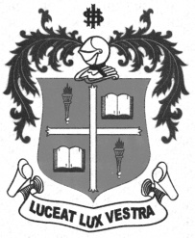
LOYOLA COLLEGE (AUTONOMOUS), CHENNAI – 600 034
B.A. DEGREE EXAMINATION - ENGLISH LITERATURE
FIFTH SEMESTER – APRIL 2011

EL 5401 - INDIAN FOLKLORE

Date : 19-04-2011 Dept. No. Max. : 100 Marks

Time : 9:00 - 12:00

- Write short note on any FIVE of the following oral genres (75 words only) 5 x 4 = 20
- Folklore
- Folksongs
- Proverbs
- Ballad
- Folktale
- Snake dance
- Elegy
- Lullaby

- Answer in paragraph any FOUR of the following in not less than 150 words. 4 x 10 = 40

- What is the prominence of Kaavadi Aatam, Poikkal Kudirai, Bommalattam, Silambattam?
- What are the characteristics of Folk Music?
- State the significance and relevance of ‘Karagatam’ in the village temple festivals.
- Mention the various beliefs and superstitions still prevalent in the villages today.
- Describe the various characteristics of folklore.

- Attempt an essay on any TWO of the following in 300-500 words: 2 x 20 = 40

- Bring out the various forms of folklore prevailing in the tradition of ours.
- List out the reasons why the birth of the first child after the marriage is a great event in any household.
- What are the very many fairs and festivals celebrated in our Tamil tradition?
- How are the popular musical instruments classified and do mention the names of such instruments?

*****

